**Review-1**

**Title -** Online Quiz Management System (web application)

**Team members -** Rishi Dinesh (19BAI1009), Pranav Balaji (19BAI1151)

**Abstract**

This online quiz management system is a web application that helps bypass the tedious process of conducting and evaluating a manual examination. This system is built with integrated group facilities that can be taken advantage of by institutions and organisations. One major highlight of this system is the different levels of abstraction available during quiz/group creation. Users can either join or create groups to share and attend private quizzes or can also search for and attend public quizzes on topics of their own interest. It is also equipped with an auto grading system that helps evaluate objective type questions. It is also enabled with a two-way feedback system that can help both the quiz organisers and the quiz takers to take suggestions and review their performance.

**Literature Survey**

|  |  |
| --- | --- |
| **Title** | **Interactive examination management system**  S. Vasupongayya, T. Kamolphiwong, S. Kamolphiwong and S. Sae-Wong |
| **Issue** | * Currently many educational information systems are focusing on developing web-based virtual classrooms to be an interaction place between instructors and students. This setting is not only useful under long-distance leaming systems, but it is also beneficial in conventional classrooms in many institutes. * To handle several online examination settings, a web-based application test management software, namely interactive examination management system (iEMS), is proposed in this paper |
| **Methods** | * Stands as a support for LMS (Learning Management System) * Uses HTTPS protocol * Eight components:   1. Builder: Creates and updates questions. There are seven types of questions available: MCQ, Boolean, matching, ordering, fill-in-the-blanks, short answer and essay (everything except essay is auto graded).   2. Terminal: Manages the creation of examinations. Can choose from two forms: Examination (time limit) and Exercise (indefinite time). Additional features like random shuffling of questions and answers, setting the time limit of the examination, allowing arbitrary scores for the question, negative scores for every question on mistakes are present.   3. Search: Searches and queries the database for the questions and quizzes   4. Player: Manages the examinations, provides authorization, delivery and time limit.   5. Results and analysis: Collect and grades answers. Individual attendee’s performance can be viewed   6. Publisher: Used to export results into excel sheets   7. Shareable content and Object Reference Model (SCORM): To print an offline hard-copy of the question paper.   8. Notification: for alerts and announcements |
| **Advantages** | * Ease of use of the Graphical User Interface (GUI) - simplistic * Pre-defined user-roles on registration * Multi-media can be included in the questions * High degree of transparency to users * Results can be exported to other formats * Hard-copy can also be accessed if need be * Encourages students to attend quizzes and also increases the attendance rate |
| **Disadvantages** | * Pre-defined user-roles can be detrimental if the students want to make and distribute quizzes themselves * Freshman Engineering students and other students with inadequate computer-skills have reported the GUI to be intimidating at first * Scope for GUI enhancement * Questions and answers were encoded using semi-colons ‘;’. In the case of quizzes with programming questions this caused lots of problems. Rectified however in future releases. |

|  |  |
| --- | --- |
| **Title** | **A quiz management system based on P2P near-field communication on Android platform for smart class environments**  M. S. Abood, M. Ismail and R. Nordin |
| **Issue** | * Because smartphones are now pervasive, especially among university students, it is tempting to vision scenarios where the exchange of small amount of data on-spot can be useful with no infrastructure requirements other than the NFC-enabled smartphone itself and a smartphone app to process the data. * Although many ideas have been investigated in academia and industry alike, the environment of smart class does not seem to receive much attention among researchers, as yet * The NFC-based applications in the educational domain are still below their real potential, and the use of NFC technology in the context of a university ambient needs to be explored |
| **Methods** | * Primarily based on the utilization of NFC (Near Field Communication) * This is a attributed to the ‘Smart Cards’ in most of the android smartphones which enables wireless communications and transfer of data over small distances * NFC standards to be met for successful connections – ISO/IEC, ECMA and ETSI standards followed |
| **Advantages** | * Helpful for quizzes or examinations for a group/ batch of students * Manual presence is also expected – ensures active participation * Reduction of paper usage – a step towards environmental protection * Removes tedious processes like collecting the answer scripts and correcting them from the equation through automation * Storage is through digital medium * App can be shared via APK |
| **Disadvantages** | * Requires close proximity to connect and share data * Susceptible to disturbance of various sorts * Low data transfer rates * Vulnerable to hacking * Not every smartphone has the proper NFC specifications * Ensuring less power consumption of the mobile device throughout the examination time |

|  |  |
| --- | --- |
| **Title** | **A Project on Online MCQ Quiz Application.**  Behamanush, Hamayoon & Thakur, Babita & Daniyal, Vivek & Sharma |
| **Issue** | The process of conducting a manual examination is tedious and time-consuming. Examiners have to go through hundreds of answer sheets and meticulously grade every single one of them. |
| **Methods** | * Support for different types of users, apart from the administrative part (user-roles) * Teachers can ‘punch tests’ and students can ‘attend tests’ * Data is stored and loaded from the database in a very simple fashion * Teachers can view the performance of individual attendee * The students can view their marks but not their performance |
| **Advantages** | * Better data and end-to-end management * Reduced runtime * Simplistic GUI |
| **Disadvantages** | * Very basic functionality * Prone to hacking due to lack of encryption in database * Lack of additional features that other QMSs provide * The student is not shown his/her performance for improvement * Limited GUI * Only objective questions |

|  |  |
| --- | --- |
| **Title** | **Enhancement of Moodle learning Management System Regarding Quizzes Security and Stability Problems**  A. Y. Elmaghrabi and S. M. Eljack |
| **Issue** | * In e-Leaning management systems (like the Moodle), quiz responses are lost during online quizzes in case of a sudden short disconnection of network * Confidentiality can be compromised when the same quiz is accessed from more than one browser or computer at the same time. |
| **Methods** | The proposed work of this study is to increase the level of confidentiality of the quizzes performed in simultaneous access to the same e- quiz account from computers other than the computer specified for the Quiz, and also to handle saving the Quiz responses in case of late submission due to network failure.  Two extensions (plugins) were installed in order to enhance the quiz security and the network Stability Problems.   * Quizaccess_offlinemode plugin: control and solve network disconnection during Quiz access and to avoid losing quiz responses due to network disconnection problem. * Quizaccess_onesession plugin: when the student first enters the Quiz page, the course information (account, IP address) is recorded. If anyone tries to access the Quiz from another computer or any device simultaneously, the browser will be blocked. Accordingly, any attempt to access the Quiz from any other device will not be allowed. |
| **Advantages** | * The quizaccess_offlinemode plugin saves user response in case of network failure thus improving reliability. Students were able to continue answering the quiz and save the answers but could not submit them till the network was connected again. When the network resume connectivity, the responses were submitted and all the questions were marked successfully. * The quizaccess_onesession plugin prevents multiple access of a quiz from different browsers or devices thus ensuring integrity and improving efficiency. When the quiz starts, we try to log in to the quiz using one of students account who is taking the quiz from another computer, the result is that; the access was blocked even if the attempt was implemented by using different browsers. Also, this restricted access data was recorded and this Login is reviewed in the login reports |
| **Disadvantages** | * This study focuses only on the Moodle learning platform and hence the proposed solution was designed exclusively to enhance the security performances of the Moodle quizzes. |

|  |  |
| --- | --- |
| **Title** | **Offline web application and quiz synchronization for e-learning activity for mobile browser**  R. M. Ijtihadie, Y. Chisaki, T. Usagawa, H. B. Cahyo and A. Affandi, |
| **Issue** | * some schools do not have an such expensive infrastructure to bring their LMS to the Internet. In addition, at home, some students may have difficulties to get online access. * Exposing LMS service without sufficient security protection to the internet is a potential risk. * Some schools may be unable to provide sufficient bandwidth to provide external access to their LMS. |
| **Methods** | Two main features of HTML5 were used. Web storage and offline web application feature.   * Web storage is a feature that is intended to overcome the limitation of HTTP cookies. Despite its mainly purpose is for state management mechanism, cookies can be used for storing information at client side, at limited size. Using Web storage, client side will have enough space for storing more data. * In order to making it capable to operate while offline, Offline web application feature is used. Offline web application allows set of HTTP objects is able to be accessed from browser without having to connect to Internet. such set is specified by developers through so-called manifest file that is included during deployment of HTML files |
| **Advantages** | * Students who enrolled in a course given a quiz assignment can choose either to do it online (during their time on school) or offline (during their time off the school) using their mobile phone. * At home, the students can view and work on the quiz. Before the deadline date, during their time on school, students can submit their work. After submitting the work, students can still view their work on their mobile phone including the past work they have submitted but they cannot resubmit their work once they have submitted. * To prevent cheating, the quiz question will be packaged and encrypted thus each student only have access to their own quiz |
| **Disadvantages** | * It is based on the assumption that students are using mobile phone capable of Wi-Fi connection. |

**Existing system**

The existing quiz management systems are usually found as a part of larger Learning management systems such as the Moodle. These systems are equipped with basic functionalities to handle quiz creation, management and evaluation. Users are allowed to choose from a variety of question types, both objective and subjective. These systems also give importance to the security aspects of their products. Efficient measures are taken to prevent unauthorized or simultaneous access to quizzes. Protocols have been implemented to ensure that the quiz data is not lost in the case of a brief network disconnection. Since network connectivity can be a big issue in this domain, methods have been proposed that allow students to take offline quizzes at home that can later be uploaded to the university server on campus as and when network connection is established. A few ingenious systems even use NFCs and smart cards to securely connect android smartphones within a close range and conduct quizzes.

**Limitations of existing system**

Security is always a big challenge when it comes to online tests. Regardless of the level of encryption of the system, it will somehow always be vulnerable to cyber-attacks and loopholes. Network connectivity is another major problem. Users need to have a stable network connection while taking quizzes and any disruptions may result in loss of quiz data. Another noticeable shortcoming is the lack of a feedback system. This creates a communication gap between the quiz organizer and the quiz takers. Scalability is also often a challenge. The system’s storage capability and processing efficiency should not waver as the number of responses to a quiz with a lot of questions increases.

**Proposed System**

The proposed method is to build an online quiz management system with integrated group facilities where registered users can either create or attend quizzes. Each quiz that is created is grouped under one of three visibility modes (which can be changed by the quiz creator at any point of time). Users can create groups by adding other users to it as members (each user is uniquely identified on the website using a user ID). Groups can also be public or private. Both the quiz organiser and the quiz takers can submit feedbacks to each other. A search bar at the top of the user home page allows users to search for quizzes, groups or other users.

**System Architecture**

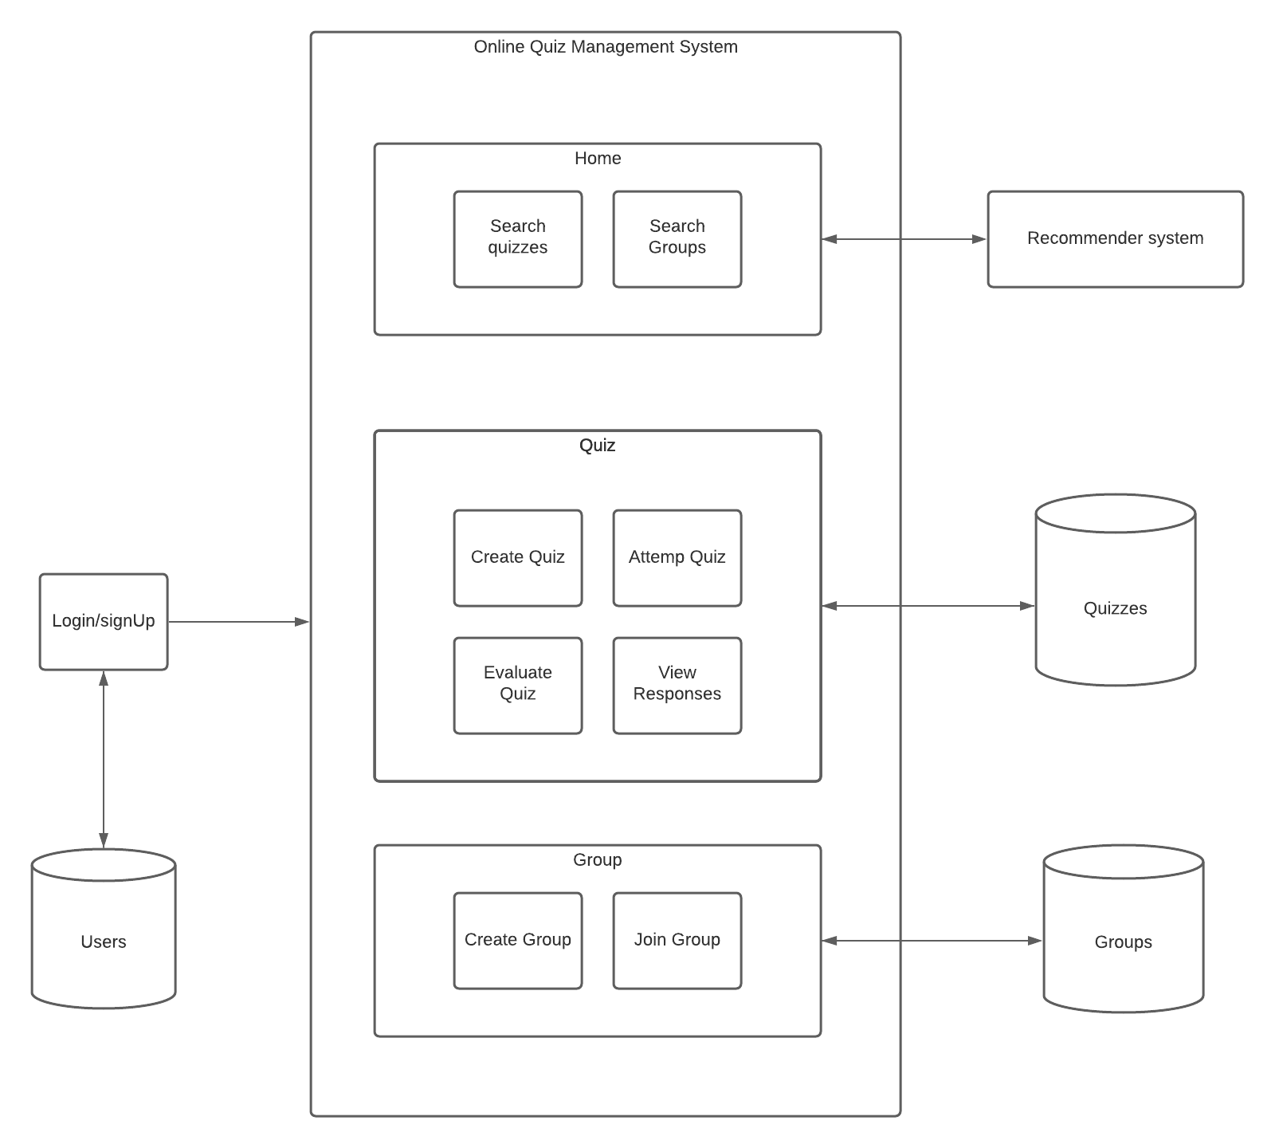

**Entity Relationship Diagram**

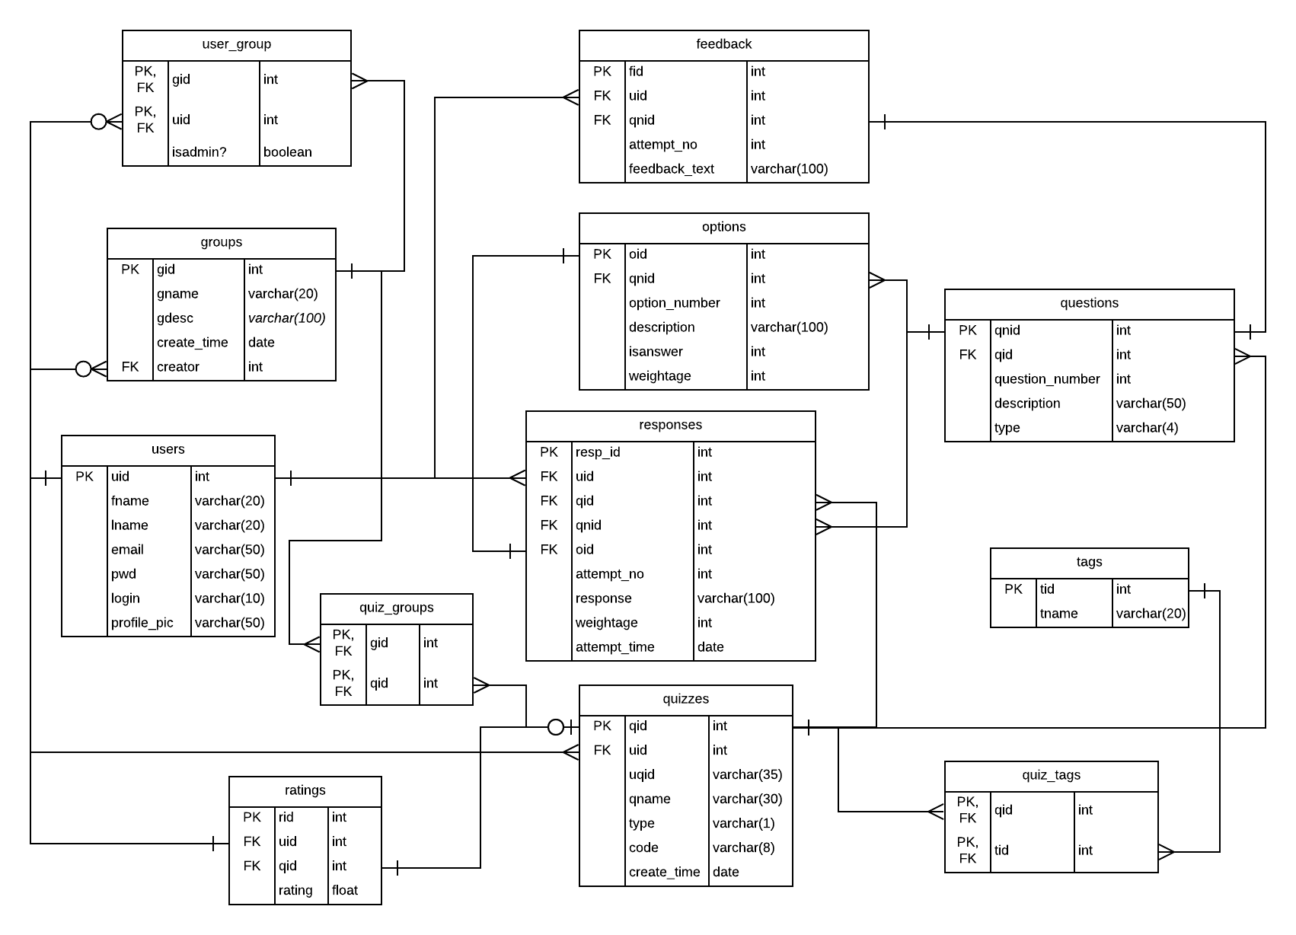

**Algorithms/techniques used**

*Authentication protocol*

Available protocols - OpenID Connect, OAuth 2.0, SAML 2.0

Selected protocol - OAuth 2.0, unlike so many other authorization protocols, does not share user attribute information with the requesting application in question. OAuth 2.0 does not expose the method by which an end-user confirms their identity to the application. Instead, the OAuth system provides a token when requested for authentication. In this application OAuth 2.0 authorization is used to implement a Google sign-in, thereby allowing the user to sign-in with their google account.

*Recommender system*

Selected model - Content Boosted Collaborative Filter (CBCF)

About CBCF: This machine learning based sequential model works in three stages:

Content Filterer - The first stage of the three-stage system, this filter uses attributes such as the quiz tags and the creator name to filter out relevant quizzes based only on the quiz features.

Collaborative Filterer - The output of the content filter is fed into the KNN model of the collaborative filter that uses the user’s ratings to capture the user’s interests and outputs a list of quizzes that are tailored to the user’s preferences.

Keeping in mind the fact that the user’s tastes are likely to change over time, the output of the collaborative filter is passed on to an SVD (Singular value decomposition) model that helps to account for this dynamic change. The SVD predicts the user’s ratings about the filtered quizzes, and recommends the most favourable quiz for the user. It also compensates for the sparsity in user-rating matrix.

**Implementation snapshots (30%)**

***Landing page*** of the website. Bordered at the top with a navigation bar containing the login and signup buttons.

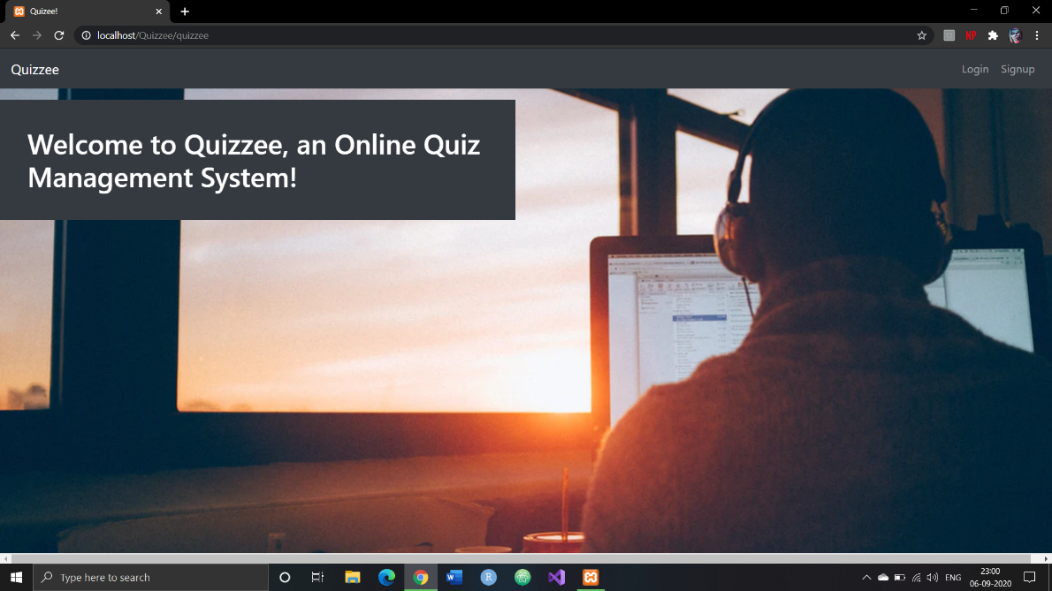

***Login page*** with text boxes prompting for the email and password. Login with Google option also available.



The ***user dashboard page*** displaying a list of all the created quizzes and the available quizzes.

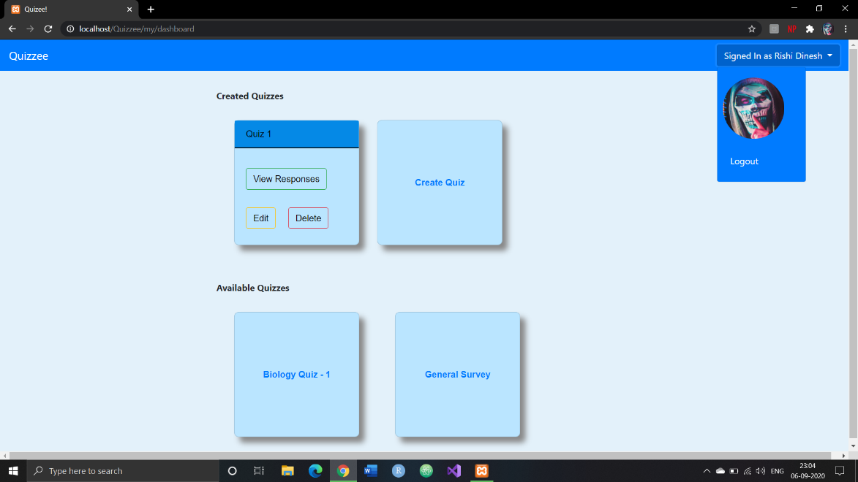

The ***quiz create page***. User can select the type of quiz (public or protected), set the number of questions and options and enter the question and option descriptions along with the allotted marks for each option (flexible grading system). The user can also dynamically view the preview of the quiz on the right-hand side of the page.

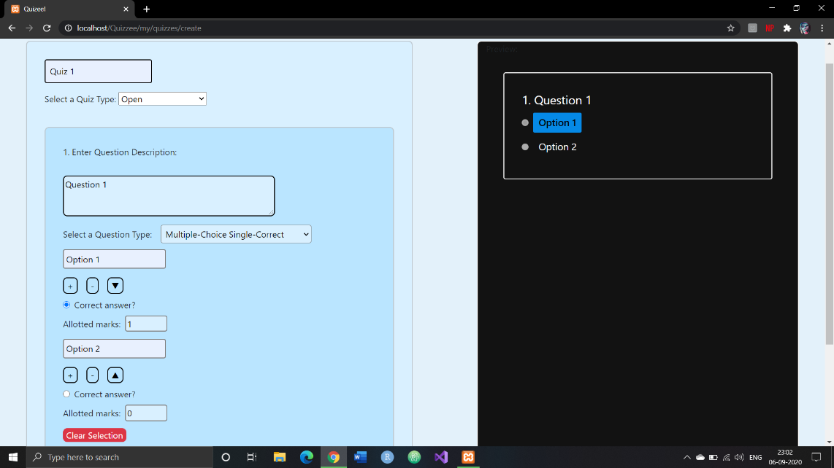

***Protected quiz attempt confirmation page****.* If the quiz is protected, the user will be prompted for a quiz code. Upon entering the correct code, the user will be directed to the quiz attempt page.

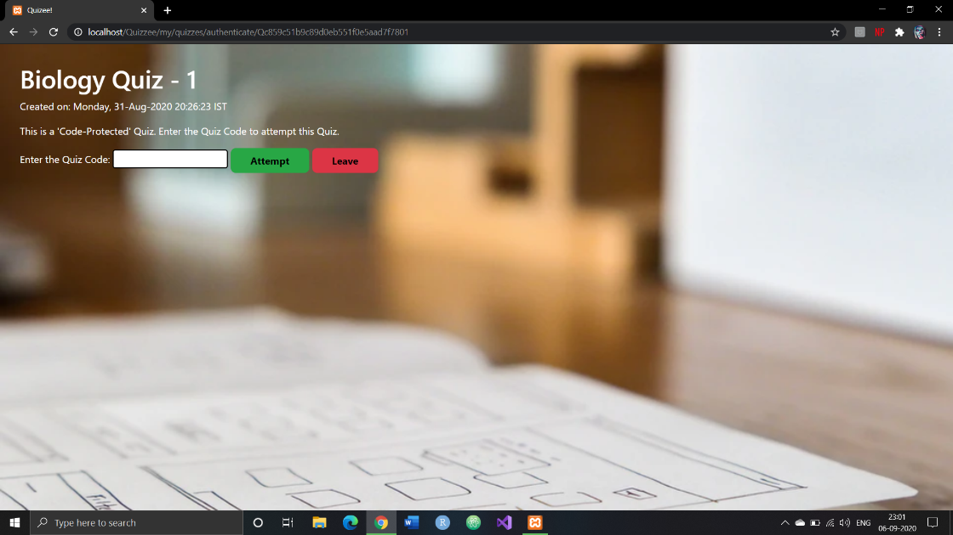

***Public (open) quiz attempt confirmation page***. If the quiz is public, the user can simply click on the attempt button to move to the quiz attempt page.

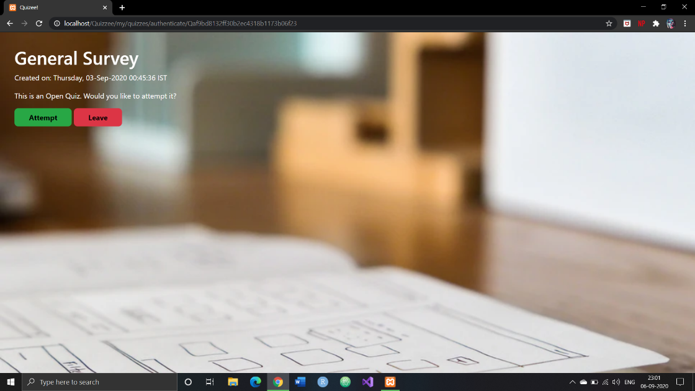

The ***quiz attempt page*.** The user will see a list of questions and options displayed in a random, shuffled order.

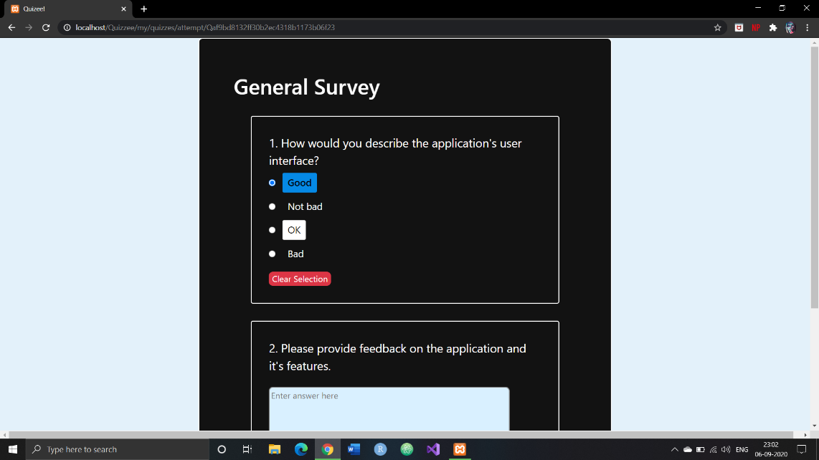

For any quiz, the user can see a **list of previous attempts** in the ***quiz attempt confirmation page*.**

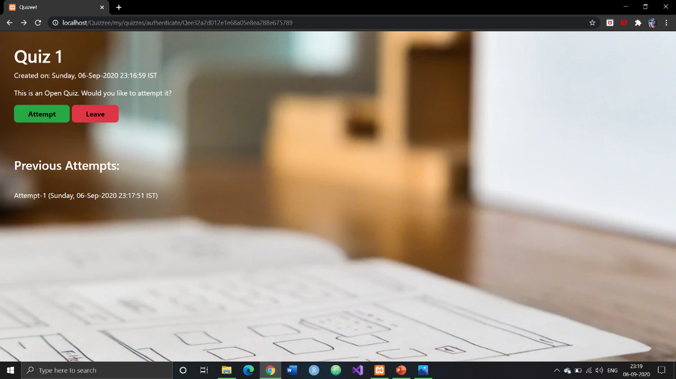

For created quizzes, the user can see a list of all responses in the ***view responses page****.*

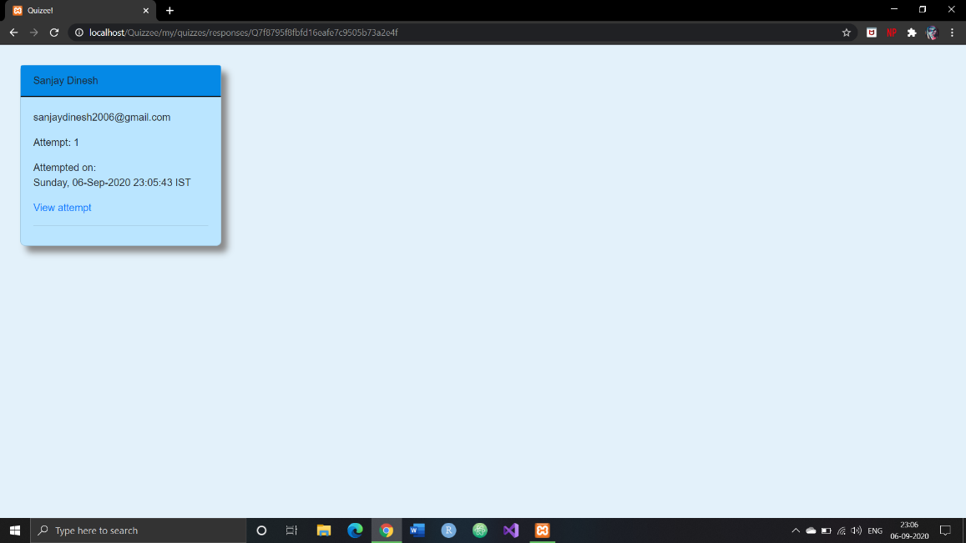

On clicking a particular response, the user will be directed to the ***quiz evaluate page*** wherein all the MCQs will have been graded by the auto grading system. The user can evaluate the descriptive questions and send question-wise feedbacks.

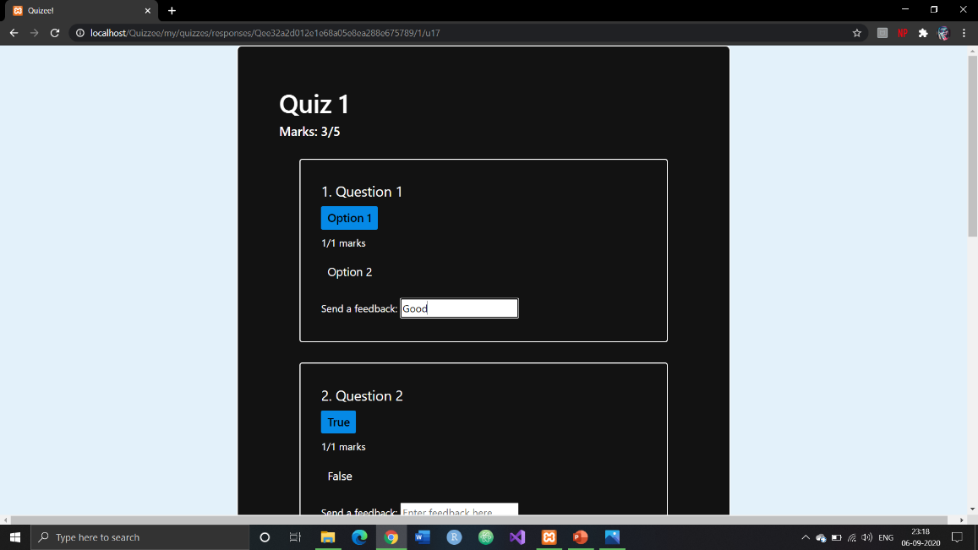

Clicking on one of the previous attempts in the quiz attempt confirmation page will take the user to the ***view score page*** wherein the user can view the total score and the feedbacks.

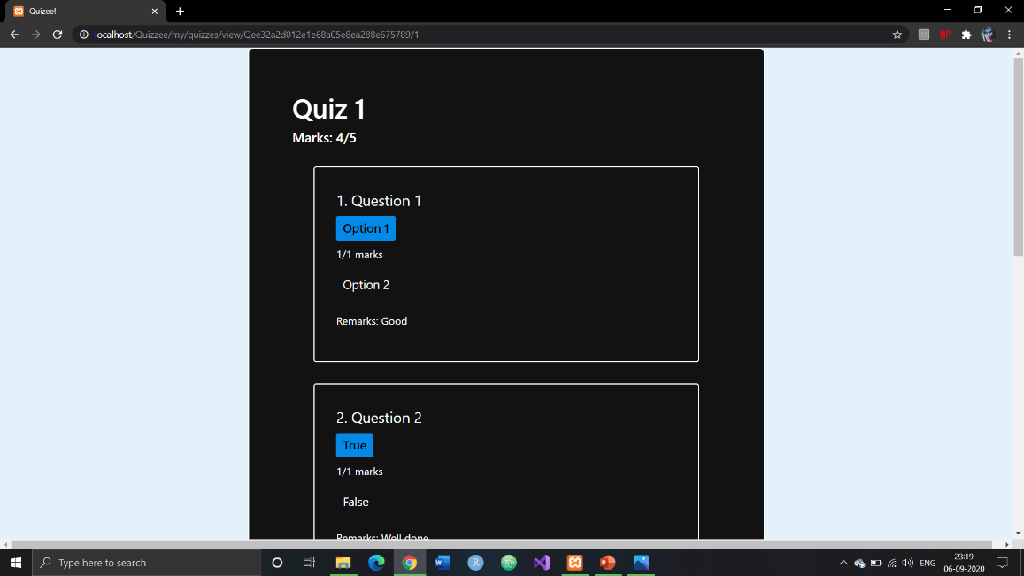

**References:**

1. S. Vasupongayya, T. Kamolphiwong, S. Kamolphiwong and S. Sae-Wong, "Interactive examination management system," 2010 2nd International Conference on Education Technology and Computer, Shanghai, 2010, pp. V2-55-V2-59, doi: 10.1109/ICETC.2010.5529435.
2. M. S. Abood, M. Ismail and R. Nordin, "A quiz management system based on P2P near-field communication on Android platform for smart class environments," 2016 International Conference on Advances in Electrical, Electronic and Systems Engineering (ICAEES), Putrajaya, 2016, pp. 83-88, doi: 10.1109/ICAEES.2016.7888014.
3. Behamanush, Hamayoon & Thakur, Babita & Daniyal, Vivek & Sharma, Dr. (2018). A Project on Online MCQ Quiz Application. 10.13140/RG.2.2.10583.83369.
4. A.Y. Elmaghrabi and S. M. Eljack, "Enhancement of Moodle learning Management System Regarding Quizzes Security and Stability Problems*,"*2019 2nd International Conference on Computer Applications & Information Security (ICCAIS), Riyadh, Saudi Arabia, 2019, pp. 1-7, doi: 10.1109/CAIS.2019.8769530.
5. R. M. Ijtihadie, Y. Chisaki, T. Usagawa, H. B. Cahyo and A. Affandi, "Offline web application and quiz synchronization for e-learning activity for mobile browser," TENCON 2010 - 2010 IEEE Region 10 Conference, Fukuoka, 2010, pp. 2402-2405, doi: 10.1109/TENCON.2010.5685899.